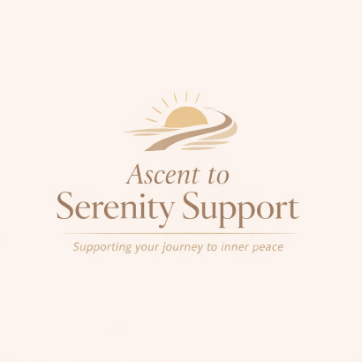
Ascent to Serenity Support

Consent Form

Client Details
Full Name:
Address:
Date of Birth:
Telephone Number:
Email Address:

Consent Statement
I confirm that I am 18 years or older and voluntarily consent to engage in services provided by Ascent to Serenity Support.

Understanding of Service
I understand this is a non-clinical emotional support service and not a replacement for therapy or medical care.

Confidentiality
I understand that confidentiality will be maintained except where there is a safeguarding concern or legal requirement to disclose information.

Data Protection
I consent to my data being stored and processed in line with the Privacy & GDPR Policy.

Signature
Signature:
Date:

